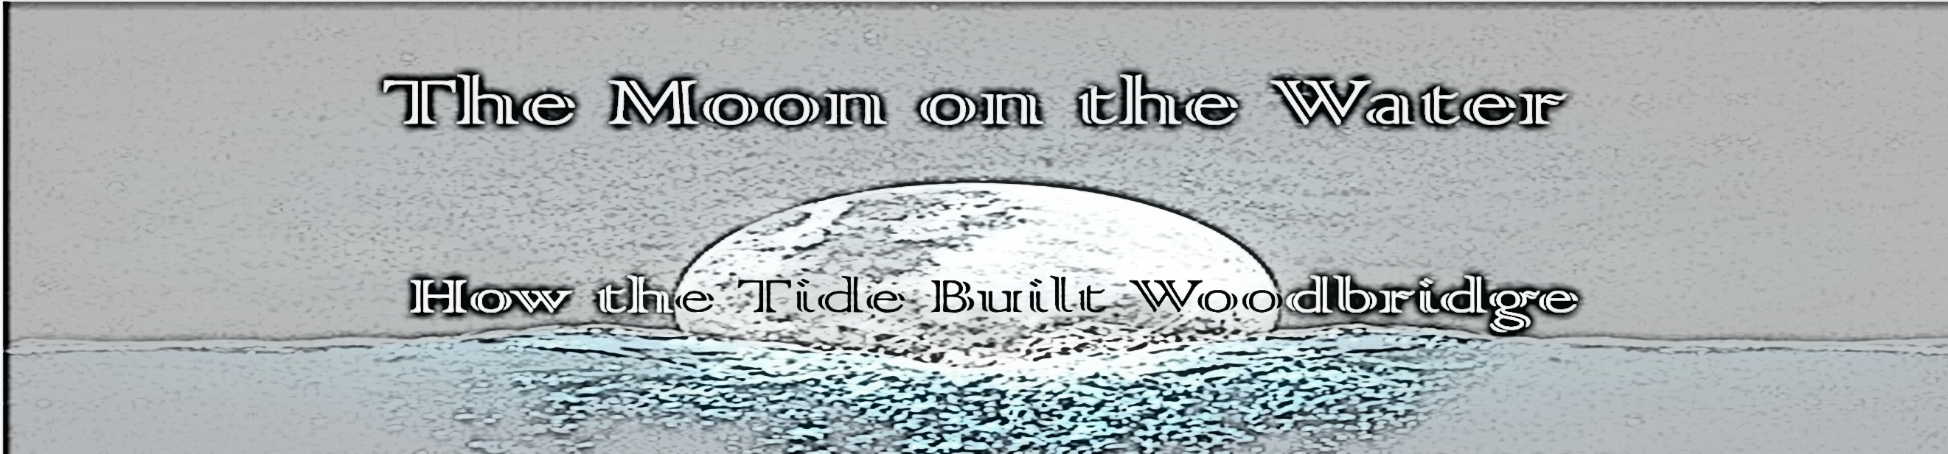

**A video presentation at Woodbridge Tide Mill Museum to complement**

**Woodbridge Riverside Trust’s “Going with the Flow” programme; 16-27 October 2019**

**Free to view with Museum Admission**